

Office of Academic Affiliations
(Application forms and mandatory training)
http://www.va.gov/oaa/app-forms.asp
Dr. L. Chad Hood, Associate Chief of Education (VA)

UF HOUSE STAFF Webpage Information
http://adminaffairs.med.ufl.edu/graduate-programs/housestaff/
VA Human Resource Contact
Mr. Kenneth Davis
Human Resources Specialist
(352) 548-6000 X3310

Revised
02/16/2016

UF/VA RESIDENTS INFORMATION HANDBOOK

TABLE OF CONTENTS

Page 3-4 UF/VA Residents Information Sheet

Pages 5-6 VA Contact Names and contact information

Page 7 Sample RCVL letter (Resident Credentialing Verification Letter)

Page 8 Sample RCVL list (Resident Credentialing Verification List)

Page 9 Sample Resident Orientation sheet

Page 10 Sample Monthly Resident Time Sheet

Page 11 Sample Quarterly Resident Time Sheet Report

Pages 12-13 General Guidelines to Posting Residents

Page 14 PGY Level “Helpful Information”

UF/VA Residents Information Sheet

Resident/fellow applications should be completed by April 30th and sent over to the Secretary to the Executive Assistant/Chief of Staff.

Please check the application VA Form (10-2850D) for completeness with signatures/dates. To be used instead of VA Form 10-2850b. This form is to be used by all residents and health professions trainees, whether Paid or Without Compensation (WOC).

If the resident is a U.S. Citizen by birth, please submit application form 10-2850d.

If the resident/fellow completed his/her medical training outside the United States, please attach a copy of their Educational Commission for Foreign Medical Graduates (ECFMG) certificate.

If the resident was born outside the United States or territory, we will also need a copy of their Naturalization Certificate, Permanent Resident Card, J-1 Visa or H1B1 Vista.

All applications along with the above documentation should be sent to the VA with the Resident Credentials Verification Letter (RCVL) and Resident List (RCVL).

Applications are processed in the order they are received. The address to send all information is as follows:

NF/SG Veterans Health System
Chief of Staff’s Office
Attn: Rose Egan, Secretary to the EA/COS
Box 100017, JHMHC
CAMPUS

During the academic year (AY), if a resident should change his/her name, the following documents need to be sent to address above:
- Copy of new Social Security Card (showing name change)
- Copy of marriage or dissolution certificate
- Copy of State Medical License (showing name change) if applicable.

WOC (without compensation), Applications are processed the same; only difference is the resident does not get paid by the VA. Any federally funded line such as the Military or National Institute for Health. The other WOC House staff will be Radiation Oncology and GYN.

NOTE: If the resident/fellow will be practicing under their previous name there is no need to change name in the system.

continued

UF/VA Residents Information Sheet

Please send any changes to insurance coverage, citizenship status or advancement; to the next PGY level; to the below address or by via e-mail.

NF/SG Veterans Health System
Chief Of Staff’s Office
Attn: Rose Egan, Secretary to the EA/COS
Box 100017, JHMHC
CAMPUS

Please keep copies of anything you send through campus mail to our office, in case it is not received we can then and only then accept a copy.

Prior to the start of the new academic year, there is an orientation to the VA that is provided by each of the services which include computer security, fingerprinting, and general information for the service that the resident/fellow will be rotating. Please contact your respective contact person for the date and time of this orientation. Please see Sample Orientation sheet in your packet

Note: The procedure for new residents or new fellows is the same. The only time you will receive applications on fellows is if they are new to UF House staff training.

VA Personnel Contact Names & Numbers
SERVICE |  | NAME | PHONE |  | E-MAIL ADDRESS
Chief of Staff's Office |  |  | 374-6018
Secretary/ Time keeper Coordinator |  | Rose Egan | 376-1611 ext. 6645  271-4526 Fax |  | Rose.Egan@va.gov
Anesthesiology |  | Johnna Criswell | 376-1611 ext.4861 |  | Jonna.Criswell@va.gov
Cardiology |  | Kathy Weinstein | 376-1611 ext.6324 |  | kathy.weinstein@va.gov
Cardiothoracic Surgery |  | Nicole Fisher | 376-1611 ext. 6470 |  | Nicole.Fischer2@va.gov
Dermatology  Dermatology (GNV) |  | Yahna Young (PGY3)  Anita (Jeannie) Baker | 352-337-4921 |  | Yahna.Young@va.gov  Anita.Baker1@va.gov
Endocrinology |  | Christine Handley | 376-1611 ext: 6438 |  | Christine.Handley@va.gov
Family Practice |  | Anita Baker | 376-1611ext. 6078 |  | Anita.Baker1@va.gov
Gastroenterology (GI) |  | Latasha Dunning | 376-1611 ext. 6429 |  | Latasha.Dunning@va.gov
GRECC |  | Soto-Garcia, Joanna | 376-1611 ext. 6077 |  | Joanna.Soto-Garcia@va.gov
Hematology  /Oncology |  | Rosemary Montgomery | 376-1611 ext. 6102 |  | Rosemary.Montgomery@va.gov
Infectious Disease |  | Cindy Dunbar | 376-1611 ext. 6438 |  | Cynthia.Dunbar@va.gov
Internal Medicine |  | Naomi Nelson | 376-1611 ext.4014 |  | Naomi.Nelson2@va.gov
VA Personnel Contact Names & Numbers
Neurosurgery | Margaret Hill |  |  | 376-1611 ext. 6903 |  | Margaret.Hill@va.gov
Neurology | Carol Colson |  |  | 376-1611 ext. 6082 |  | Carol.Colson@va.gov
Ophthalmology (WOC) without compensation | Anna Paul |  |  | 376-1611 ext. 6061 |  | Anna.Paul@va.gov
Orthopedics | Karen Moore |  |  | 376-1611 ext. 6856 |  | Karen.Moore4@va.gov
Otolaryngology | Dawn Allen-Boswell |  |  | 376-1611 ext. 3334 |  | Dawn.Allen-Boswell@va,gov
Pathology | Pam Schafer |  |  | 376-1611 ext 6057 |  | Pamela.Schafer@va.gov
Psychiatry | Lisa Colton |  |  | 376-1611 ext. 7611 |  | Lisa.Colton@va.gov
Pulmonary | Keesha Nattiel |  |  | 376-1611 ext.6063 |  | Keesha.Nattiel@va.gov
Radiology | Allecia Munoz |  |  | 376-1611 ext. 6064 |  | Allecia.Munoz@va.gov
Surgery Administrative | Linda Kunz or  Anita (Jeannie) Baker |  |  | 367-1611 ext. 6013 |  | linda.kunz@va.gov  Anita.Baker1@va.gov
Rheumatology | Cindy Dunbar |  |  | 376-1611 ext. 6438 |  | Cynthia.Dunbar@va.gov
Surgery - General | Yameila Henry |  |  | 376-1611 ext. 6078 |  | Yameila.Henry@va.gov
Vascular Surgery | Nadine Walker |  |  | 376-1611 ext. 6470 |  | Nadine.Walker@med.va.gov
Plastic Surgery | Catherine Perkins |  |  | 374-6054 |  | Catherine.Perkins@va.gov
Urology | Nathan Mailloux |  |  | 376-1611 ext. 6468 |  | Nathan.Mailloux@va.gov
Revised
02-24-15

***PRINT ON UF LETTER HEAD***

SAMPLE “RCVL” LETTER
Attach with “RCVL” list

Date

Thomas Wisnieski, MPA, FACHE
Director
NF/SG Veterans Health System
1601 SW Archer Rd.
Gainesville, FL 32608

Dear Mr. Wisnieski:

We are attaching a list of residents that will be assigned to rotations at the NF/SG Veterans Health System during the period of July 1, 2013 through June 30, 2014. Each physician has been certified to be both physically and mentally fit to perform the duties assigned while rotating at the NF/SG Veterans Health System. Additionally, they have met all credentials and program requirements established by the University of Florida. College of Medicine in the ACGME accredited residency program. We have provided appropriate training in the proper use of biomedical equipment relevant to each specialty.

If you have any questions or require additional information, please call _______ at ______.

Sincerely,

________________________M.D.
Professor and Chairman

Recommended Approval/Disapproval Recommended Approval/Disapproval

_____________________ _____ ______________________ _______
L. Chad Hood, M.D. THOMAS WISNIESKI, MPA, FACHE
Associate Chief of Staff, Education Director

SAMPLE “RCVL” LIST
Attach with “RCVL” letter

Surgery Residents 2014 - 2015
RESIDENT NAME | SSN | PGY | SUB-SPECIALTY | INSURANCE | START DATE | END DATE | Federally Funded  (WOC) | VISA
White, Robin | XXX-XX-XXXX | 4 | Plastics | Single | 7/1/2002 | 6/30/2008 |  | PR
Taylor, Donald | XXX-XX-XXXX | 1 | General | Family | 7/1/2006 | 6/30/2010 |  | J1
SMITH, John | XXX-XX-XXXX | 3 | Cardiothoracic | Single | 7/1/2003 | 6/30/2009 | Army | Naturalized
WESTON, Paul | XXX-XX-XXXX | 2 | Urology | Family | 7/1/2004 | 6/30/2007 | NIH
WHITE, Mary | XXX-XX-XXXX | 5 | General | Single | 7/1/2001 | 6/30/2007 | Courtesy
PGP

GY L
**SAMPLE**
Medical Service Administrative Orientation for New House Staff
DATE TBA
Room A125 (Management Information Center)
1:00 PM | Welcome | Bradley Bender, M.D.  Chief of Staff
1:05 PM | Welcome | Richard Schofield  Chief, Medical Service
1:10 PM | Medical Center Safety  Escort service  General safety issues | Brannaka Colvin  Captain  Police and Security Service
1:15 PM | Medical Records  Transfer Notes, Signatures, Discharge Summaries, Electronic Charting | Delia Pittman  Supervisor  Health Information Management Service
1:25 PM | Radiology Service  Scheduling Exams, Radiology Dictation System, Checking Out Films | James Grantham, M.D.  Staff Radiologist  Radiology Service
1:35 PM | Infection Control  Blood Culture Kits, Rule out TB Needle Stick Protocol VRE, Personal Protective Devices | Robert Jenkins, CIC  Hospital Epidemiologist  Medical Service
1:45 PM | Dietetics Services  Diet Ordering Nutritional Support Team Tube Feedings On-Call Meals for Housestaff Outpatient Nutritional Supplements | Kirsten Ridgely, M.S., R.D.  Clinical Dietitian  Nutrition and Food Service
1:50 PM | Pharmacy Service  Formulary System Decentralized Pharmacists  Hours of Coverage Antibiotics, Chemotherapy TPN, Adverse Drug Reactions | Mark Burlingame, Pharm.D.  Clinical Pharmacist  Pharmacy Service
2:00 PM | Case Management  Advanced Directives DNR, Medical Care Cost Recovery, Utilization Review Performance Measures Community Placement Patient Abuse and Neglect Disposition Planning | Robin Riffee-Landa, R.N.  Case Manager  Performance Improvement Service
2:15 PM | Pathology and Laboratory Medicine  Ordering Tests (STATs),Autopsy Services  Blood Bank (including Consent Form)  Weekend Availability | Byron Croker, M.D., Ph.D.  Chief. Lab Administrator Pathology and Laboratory Medicine Service
2:25 PM | Library Service  MD Consult, Searches UpToDate | Cornelia Camerer  Librarian - Library Service
2:30 PM | Personnel Sign-In  Appointment letter, Employee affidavits  Pharmacy signature cards | Vincent Gudewich  Human Resources Management Service
2:45 PM | Health Literacy | Patty Donaldson, R.N.  Clinical Care Manager
2:55 PM | Fire and Safety Orientation  “RACE” Accident Reporting, Emergency Alarm System, Disaster Plan Responsibilities | TBA, MHA  Administrative Officer
3:05 PM | Miscellaneous  Computer Security, NT Passwords, Compliance, HIPAA | TBA, MHA  Administrative Officer
3:30 PM | Computer Training (Room EB59)  CPRS, Order entry, etc. | Wandra Haywood, M.Ed., R.N. Chief IRM

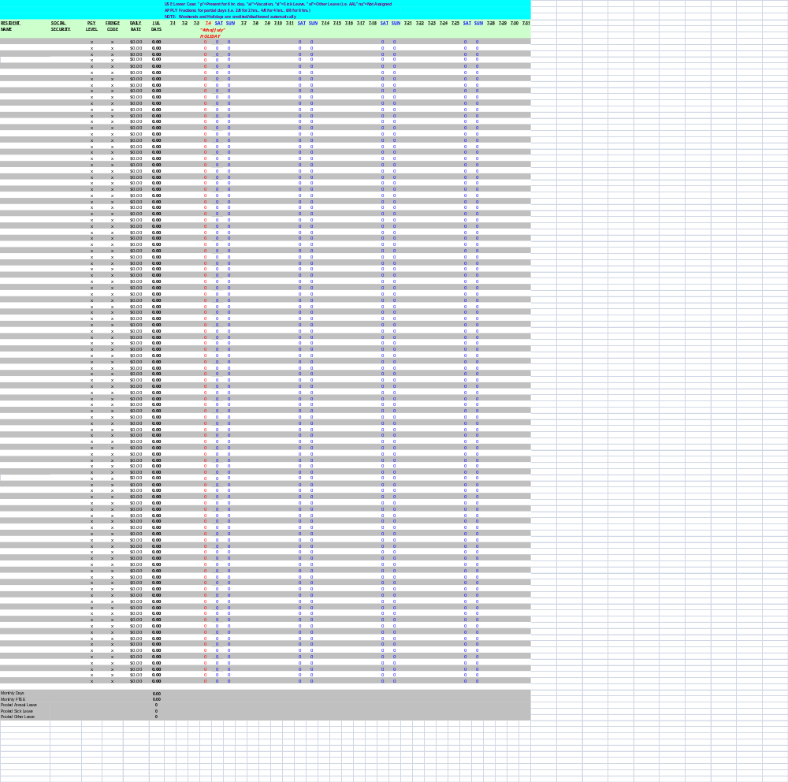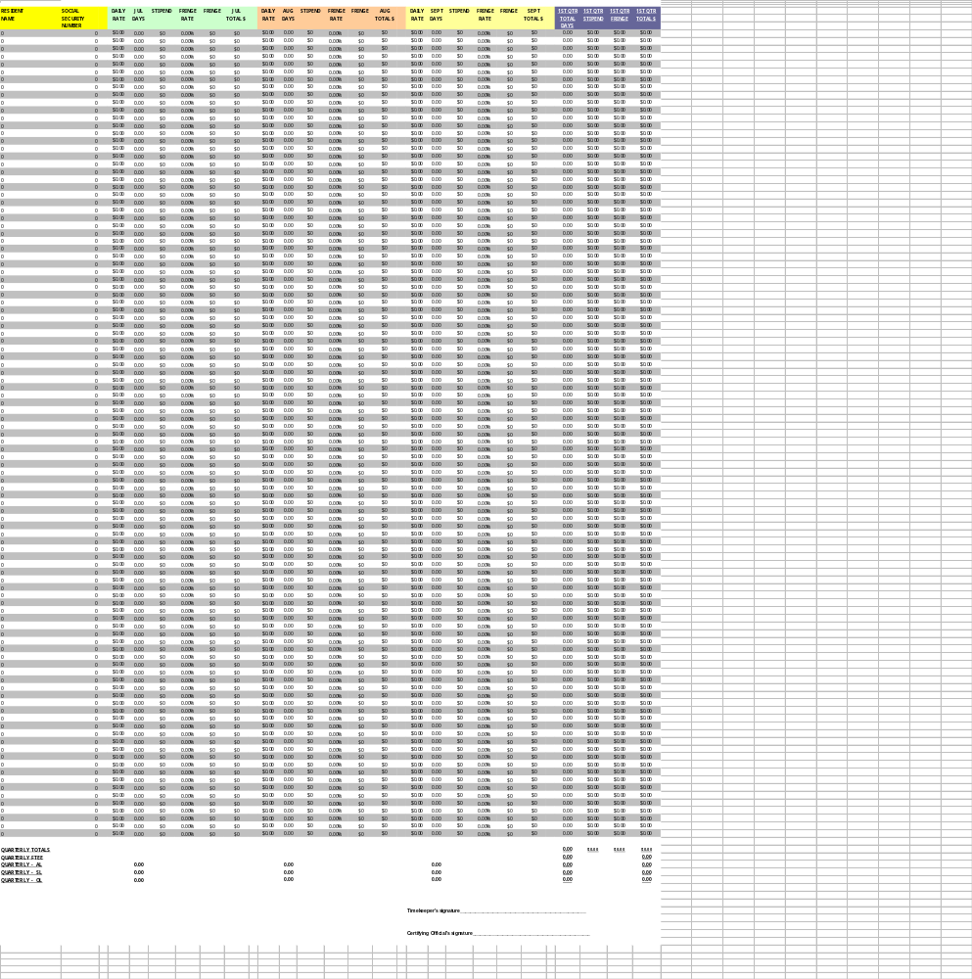
GENERAL GUIDELINES TO POSTING RESIDENTS/FELLOWS

Timekeeping for residents/fellows should ideally be done every day and will be expected to be done at least biweekly. The rotation schedules you receive from the Department of Medicine are to be utilized as a guideline only, they are not to be utilized for posting. Each one of you will be required to set up a tracking system of your own to account when the residents/fellows are present. This can be achieved in several different ways:

- Use of the subsidiary time sheets.
- Setting up a notebook with each resident/follows name to sign into every day posting from those sheets.
- Setting up a calendar for them to sign into and posting from the calendar.
- Paging them everyday OR having them call in everyday.

The Resident Time & Leave program that is set up is based on a Monday – Friday with automatic credit for call. When a resident/fellow is in an approved time or leave status on Friday, they will receive automatic credit for Saturday and the same is true for Monday, they will receive credit for Sunday. This rule is also in effect for Federal Holidays. The program is set up in increments of two (2) hour periods of time 2/8, 4/8, 6/8 and 8/8. The other approved leave status’ are as follows: AL – annual leave, SL – sick leave (which includes family sick leave including maternity and paternity leave), OL – other leave (Educational seminars, meetings, taking boards, and jury duty). When using OL please document at the bottom of the month what the OL was used for.

Annual leave, sick leave, and other leave are pooled for each department. Annual leave is pooled 15 days/resident or fellow/year. Sick leave and other leave is pooled 10 days days/resident or fellow/year. So for example: you have 10 residents/fellows in your section, 10 residents/fellows could utilized 150 days of annual leave, 100 days of sick leave and 100 days of other leave per year as a group without the department being penalized.
continued

GENERAL GUIDELINES TO POSTING RESIDENTS/FELLOWS

At the bottom of each monthly sheet you will notice Monthly Days, Monthly FTEE, Pooled AL, SL and OL: also at the bottom of the quarterly sheet you will also note that the Pooled “AL, SL, and OL will keep a running total of what has been utilized. These figures will be helpful to you and the certifying official to ensure that there is not an abuse of approved leave.

At the end of each quarter, timekeepers will be expected to print a report for each month as well as the quarterly summary. Please review the monthly and quarterly sheets after printing to ensure all data is captured; there have been times where the data has not printed and has printed and has been substituted for # signs. If this should occur, go into page setup and check the Scaling % it should be 56%. If you continue to have problems with any of the data missing please call the secretary for the Executive Assistant/COS. The quarterly summary report must be signed by both the timekeeper and certifying officer and hand-delivered to secretary for the Executive Assistant/COS (11B), the first work day following the end of each quarter.

_____________________________________________________________________________________

PGY LEVELS (helpful information)

VA can only pay up to the ACGME (Accreditation Council for Graduate Medical Education) curriculum requirement:

For example, a neurosurgery resident must complete 6 post graduate years to become board-eligible. However, UF may permit that individual to train for an additional year and pay him/her at the PGY-7 level. We can only re-appoint that person at the PGY-6.

____________________________________________________________________________________

